**PRACTICAL 2**

Aim: To Explore and Manage Raster data

1. **Adding Raster Layer**

Procedure:

* From menu bar select Layer → Add Layer → Add Raster Layer

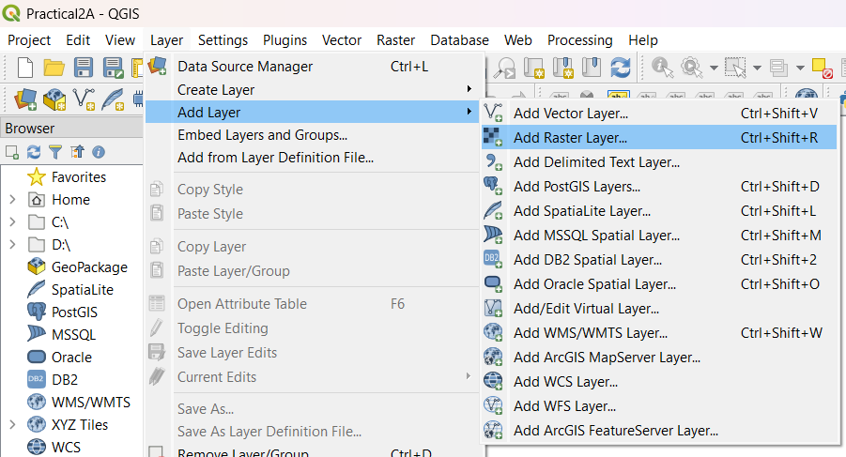

* Select Gridded Population of the World (GPW) v3 dataset from Columbia University, Population Density Grid for the entire globe in ASCII format and for the year 1990 and 2000. “\GIS_Workshop\Practicals\Practical_02\A\Data\gl_gpwv3_pdens_90_ascii_one\glds90ag60.asc” “\GIS_Workshop\Practicals\Practical_02\A\Data\gl_gpwv3_pdens_90_ascii_one\glds00ag60.asc”

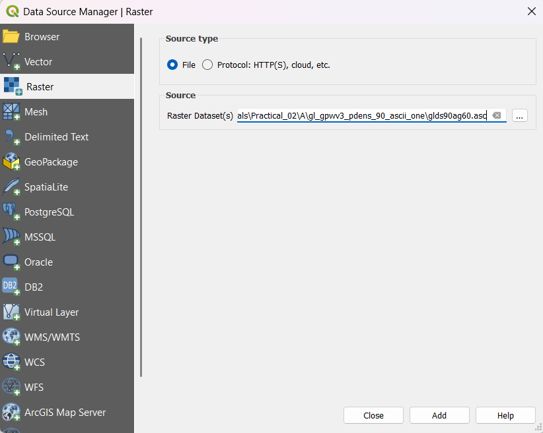

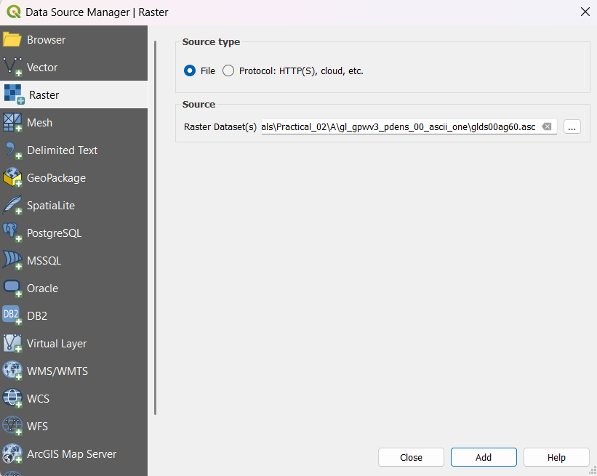

* Go to Project → Properties OR Press the Set CRS option on bottom right corner.

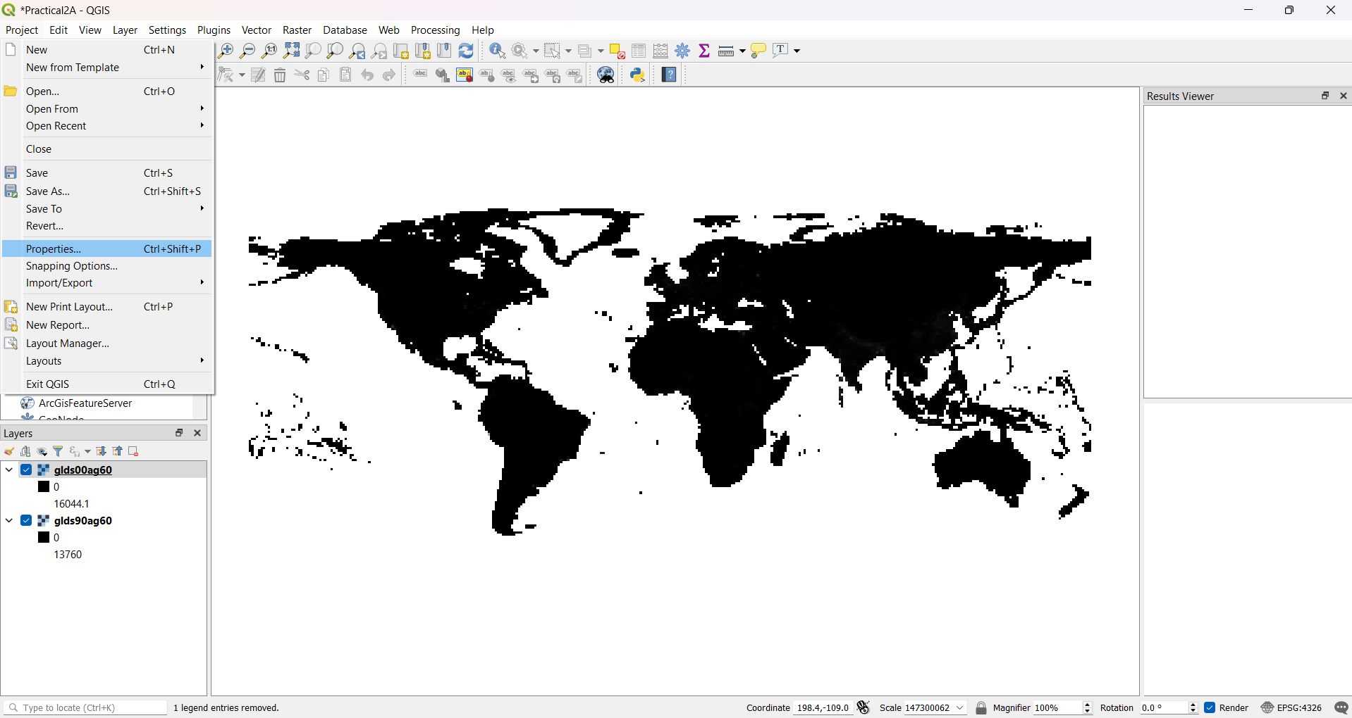

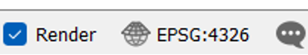

* Select WGS 84 EPSG: 4326 and Press OK

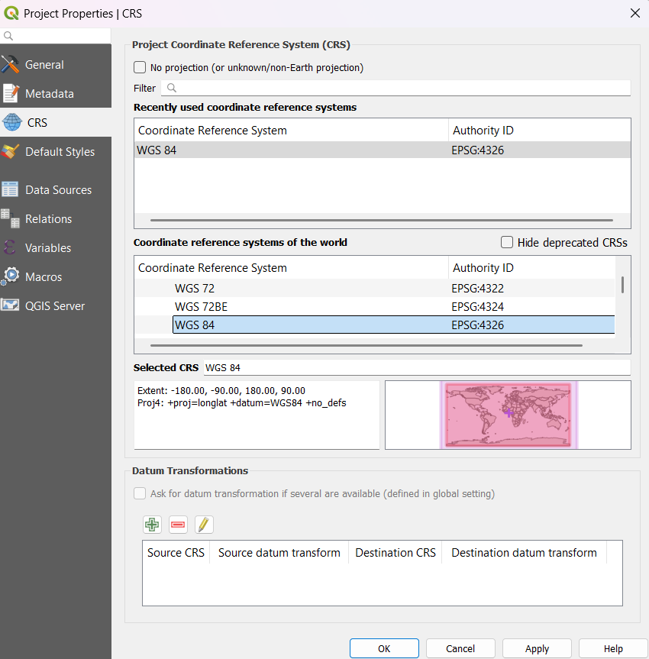

1. **Raster Styling and Analysis**

Procedure:

* To start with analysis of population data, convert the pixel from grayscale to Color. Select “glds90ag60.asc” Layer form layer Pane → select property OR double click on it. Select Symbology

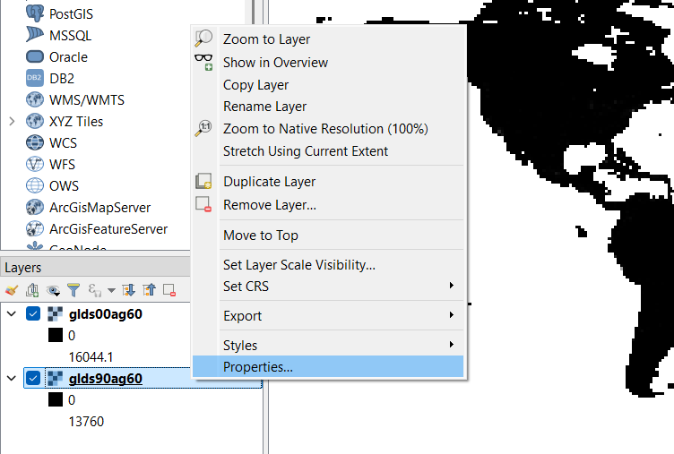

* Select Render Type as “Singleband pseudocolor”. Min=0 and Max=240. Select the Color Ramp. Press “APPLY” .

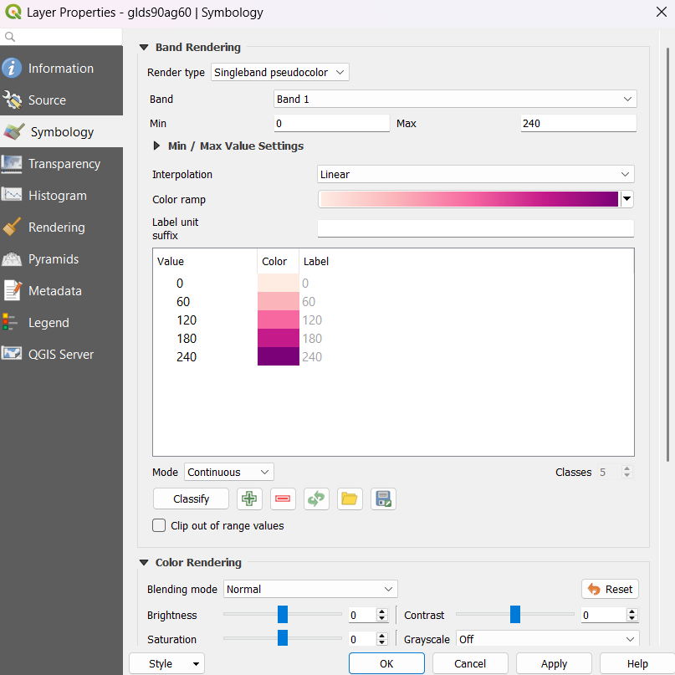

* Repeat the same for “glds00ag60.asc” Layer
* Layer output after applying style.

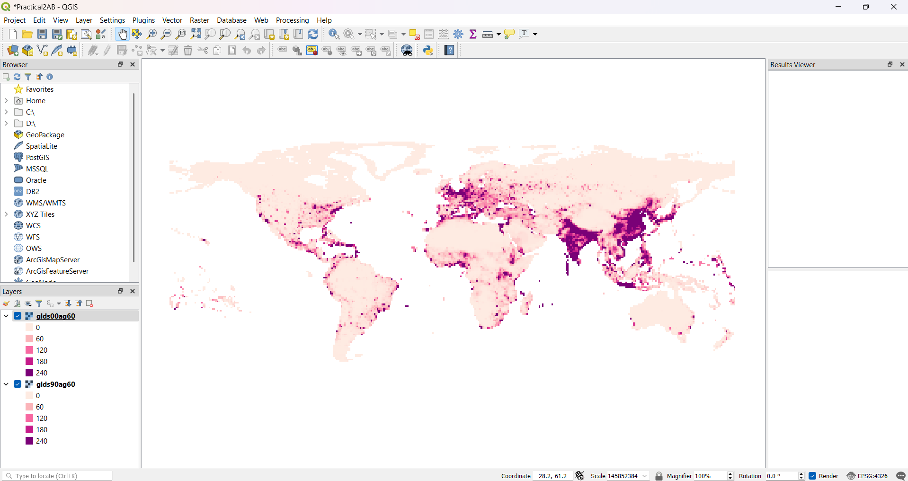

* Go to Raster → Raster Calculator

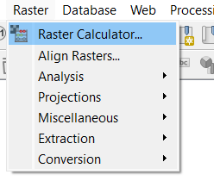

* Put the expression "glds00ag60@1" - "glds90ag60@1"
* Select the output file location & name as Pop_Diff and Press OK.

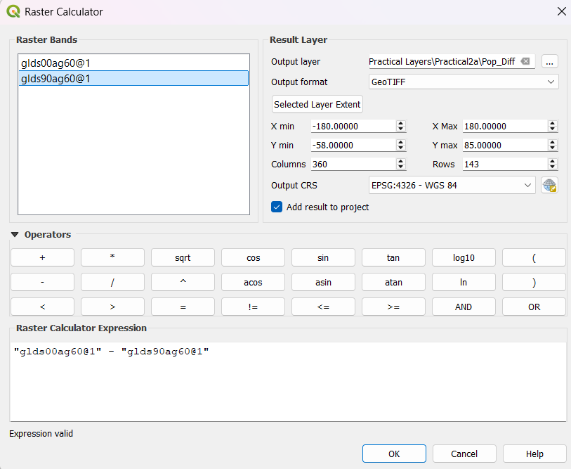

* Remove the other two layers i.e. glds00ag60.asc and glds90ag60.asc

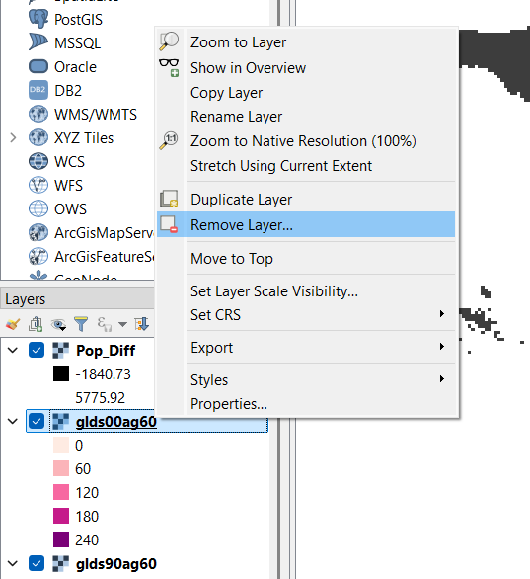

* Double click on pop_diff layer. Select Symbology
* Set Render Type to “Single band Pseudo color”, Interpolation as Discrete, and remove all classification and add as shown in figure above using button. After all settings press “OK”.

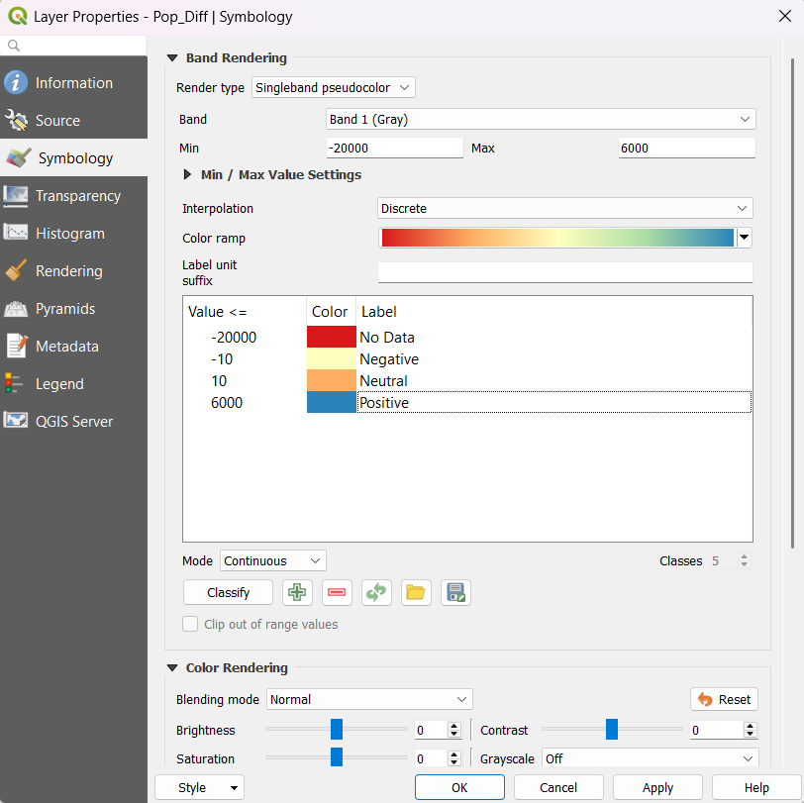

* Layer will appear like:

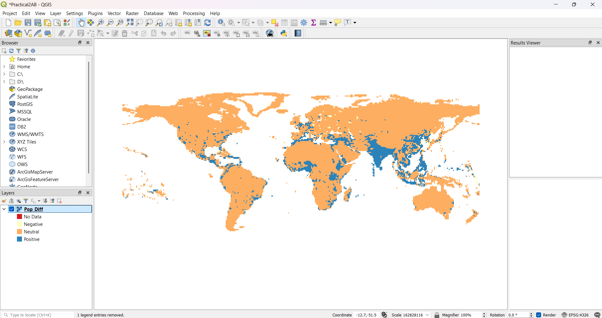

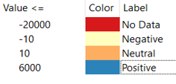

1. **Raster mosaicking and clipping**

Procedure:

* Go to Layer → Add Layer → Add Raster Layer.



* Select the following “.tif” raster images

FAS_India1.2018349.terra.367.2km.tif FAS_India2.2018349.terra.367.2km.tif FAS_India3.2018349.terra.367.2km.tif FAS_India4.2018349.terra.367.2km.tif

* Raster window click Add.

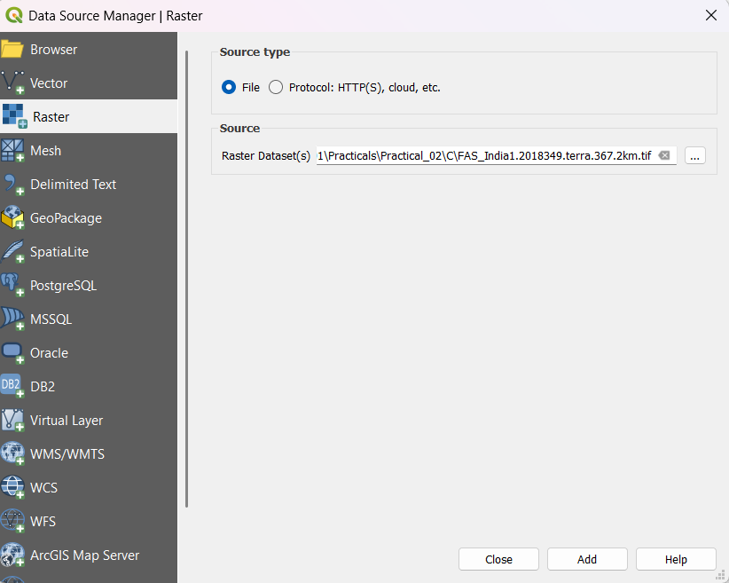

* Go to Raster → Miscellaneous → Merge

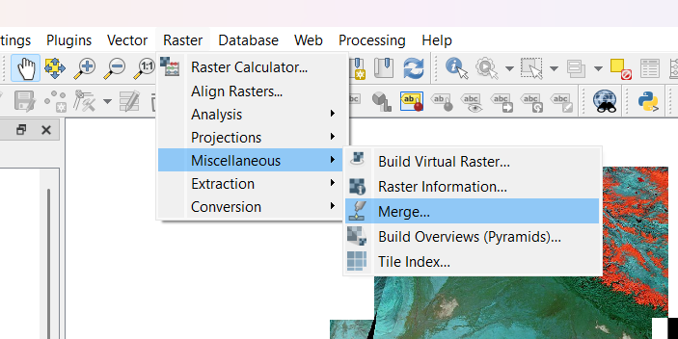

* In the Merge dialog window. Select three dots Input Layers. Select all layers and Press OK. In Merge dialog window select a file name and location to save merged images.

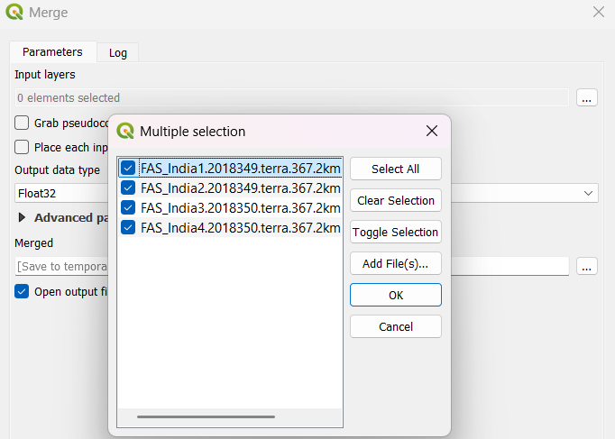

* Save the file to a location with the name as Merge_Files.tif ➢ Press Run and after completion of operation close the Merge window dialog box.

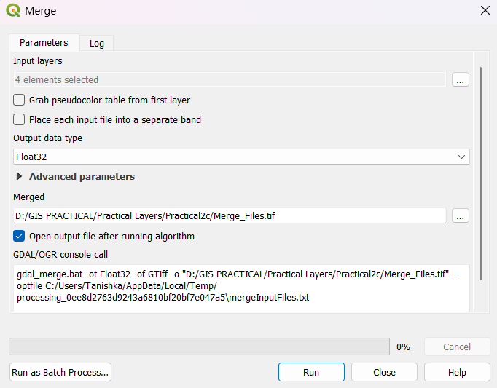

* You can now deselect individual layers from layer pane and only keep the merged raster file.

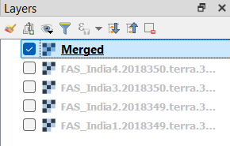

* Go to Layer→ Add Vector Layer → Select \GIS_Workshop\Practicals\Practical_02\C\IndiaAdminBoundry\IND_adm0.shp file. From layer properties → select → select any one of the following

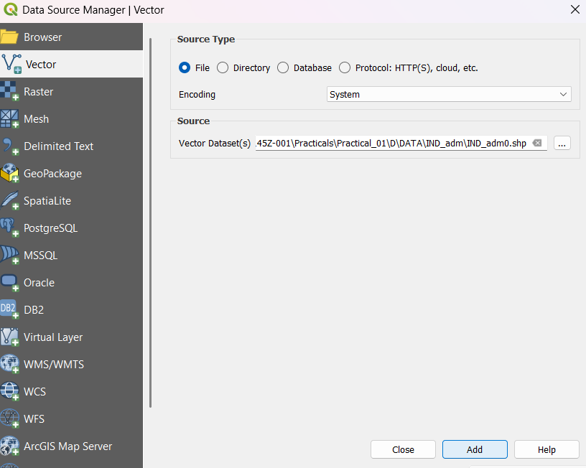

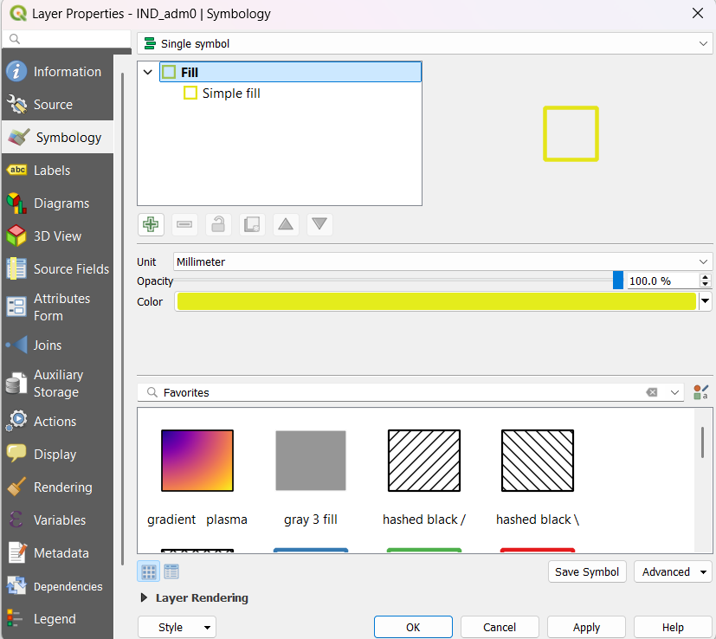

* The result will be

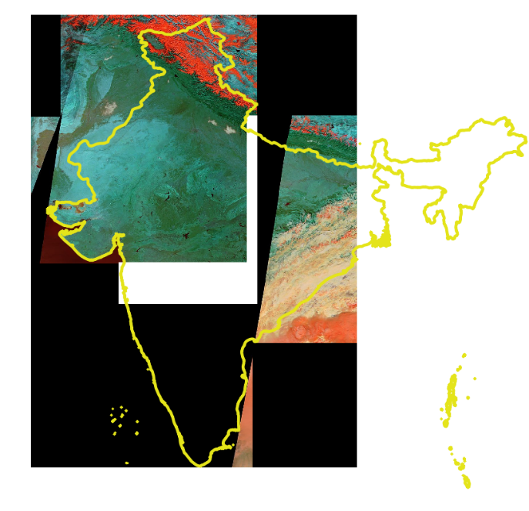

* Go to Raster → Extraction → Clip Raster by Mask Layer

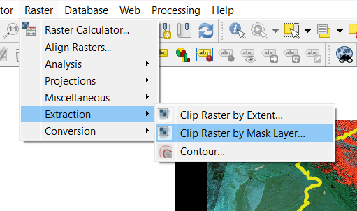

* Select the merge raster image as input and Ind_adm0 as mask layer. Select a file name and location for clipped raster as /Practical_02/C/Clipped_File.tif.

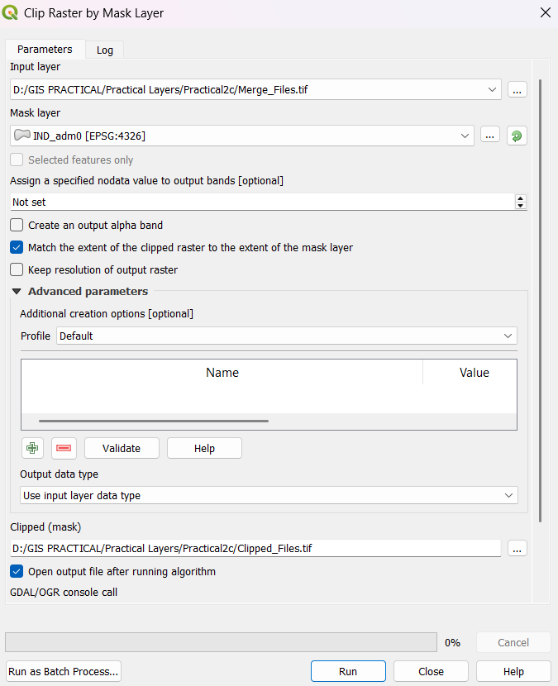

* Press RUN



After Clipping

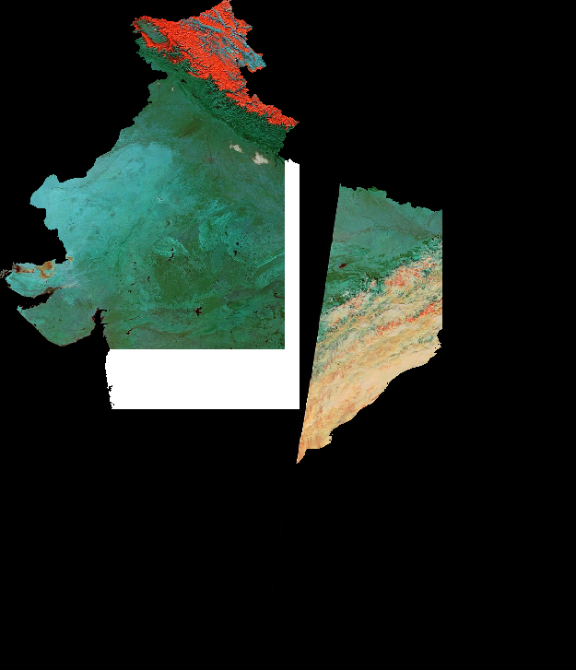

Output: Raster data has been explored and managed successfully.